When providing client with a COVID-19 home test
A San Antonio Community Health Worker guide

- Provide client with video instruction guide in their preferred language
- Advise client on how to order additional tests on www.covidtests.gov OR assist client by ordering for them, with their permission.
- Educate clients with health insurance about opportunity to order free tests from the pharmacy each month. Request COVID-19 tests from the pharmacist OR place free order on CVS.com or Walgreens.com. Have insurance information available.
  - Health plans are required to cover a maximum of eight (8) at-home COVID-19 tests without a prescription. This is available for each person on the health plan. For at-home COVID-19 test kits that contain two (2) tests per kit, a maximum of four (4) kits every 30 days are covered.
  - If you purchase an over-the-counter COVID-19 test from a pharmacy, store, or online retailer and are charged for your test, keep your receipt and submit a claim to your insurance company for reimbursement.
If a client tests positive,
- Refer to their doctor for guidance
  - Treatment is now available for ages 12+, but it must be prescribed right away. In November 2022, the CDC reported on a real-world study that showed adults who took Paxlovid within five days of a COVID-19 diagnosis had a 51% lower hospitalization rate within the next 30 days than those who were not given the drug.
  - If uninsured, they can receive testing & treatment services at CentroMed Palo Alto at no-cost.
- Advise them to stay home and wear a mask around others. Call close contacts they may have exposed.
  - People with COVID-19 can transmit it to others. Isolating at home helps keep other people from
getting sick. You should isolate regardless of your vaccination status. If a vaccinated person gets COVID-19, they can still transmit the infection to others, but being vaccinated for COVID-19 makes them much less likely to be hospitalized or die from COVID-19.

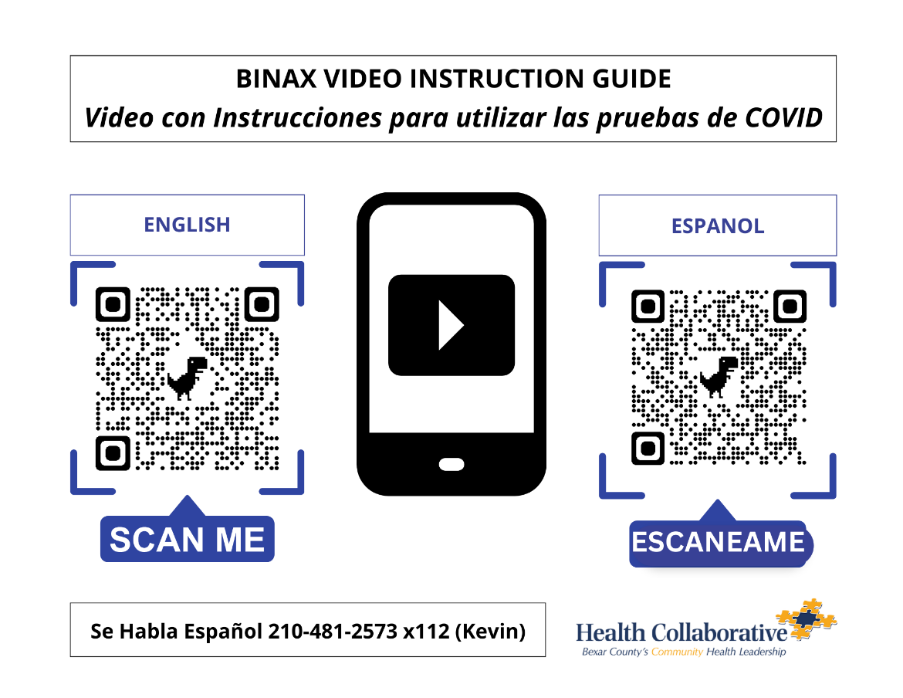
VIDEO INSTRUCTION GUIDES

